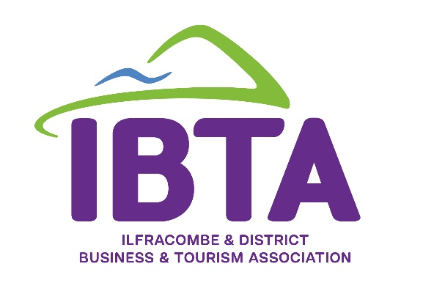
Report from the
Business Networking Event
held Monday 6th November 2023

Thank you to all businesses that attended our recent networking evening held at The Lantern. Thank you also to Philip Dennis Foodservice for their donation towards to the food, and to Eliot Seabourn-Wren, head chef at The Carlton Hotel for preparing a great spread for everyone to enjoy.

SPEAKERS:
Business Action - Speaker – Robert Zarywycz
Robert spoke about the economic challenges of recent years.
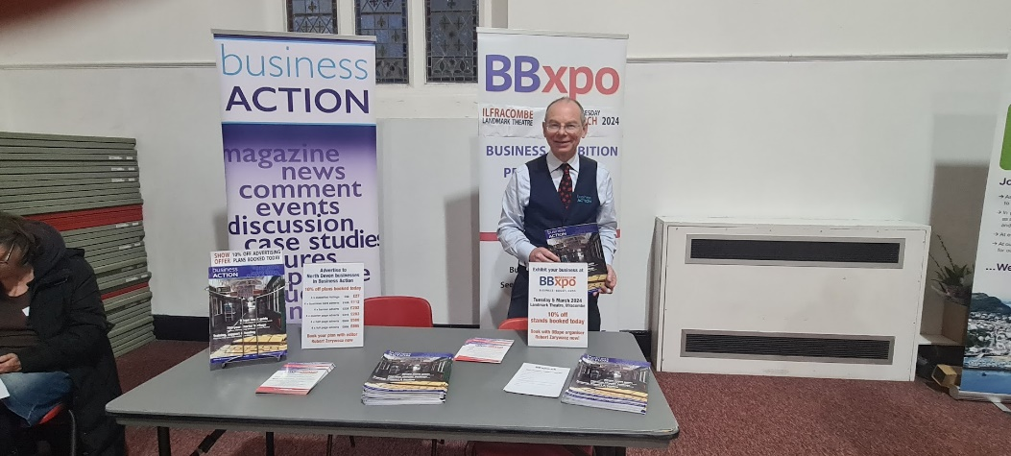
A copy of the presentation can be viewed here

North Devon UNESCO Biosphere – Speaker – Sarah Jordon, Nature Tourism Officer
Sarah spoke to us about the recent creation of the North Devon UNESCO Biosphere and how we can all get involved.
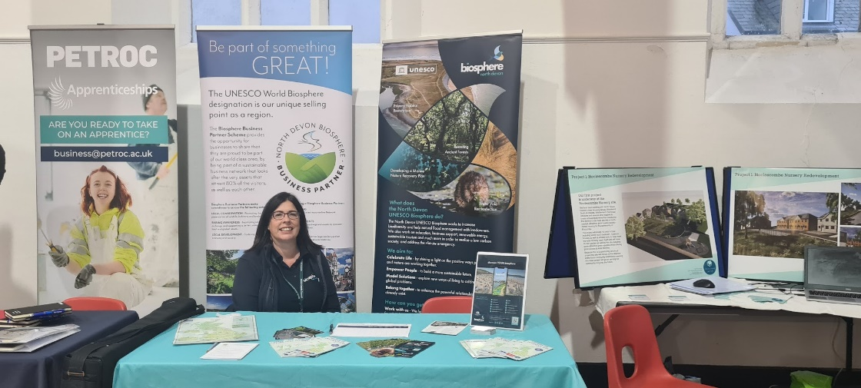
A copy of her presentation can be viewed here
Details of how your local business can get involved with the North Devon UNESCO Biosphere can be downloaded here

Local Business Exhibitors
Various local businesses exhibited at the event and it was good to all mingle and network following the presentations.
A list of attendees and links to their websites:

- Business Action
- Coversure Insurance Services
- Combe Brewing Company
- North Devon UNESCO Biosphere
- Ilfracombe Community Land Trust
- Petroc College
- Philip Dennis Food Service
- Plastic Free North Devon
- Proper Marmalade Company

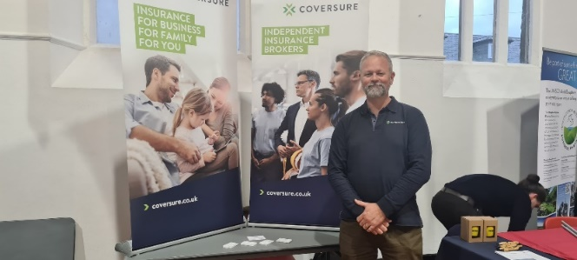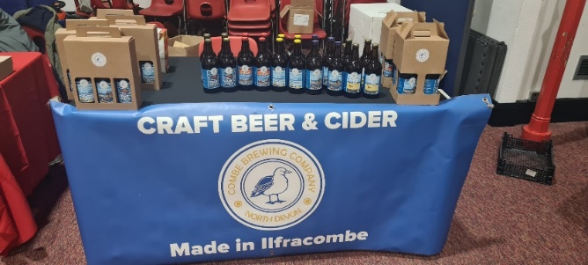
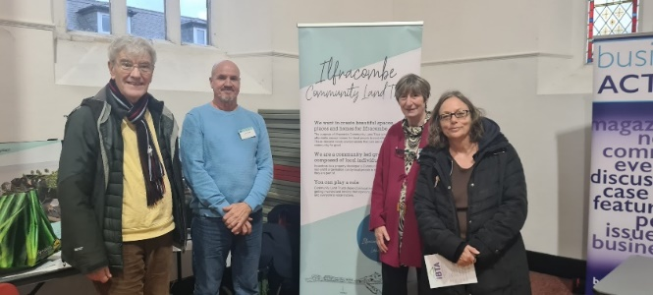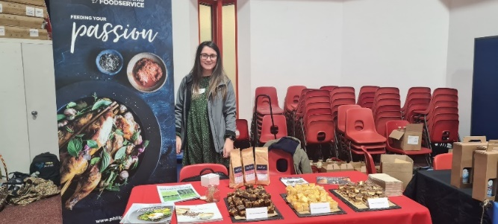
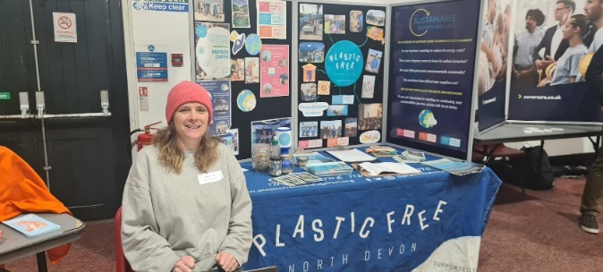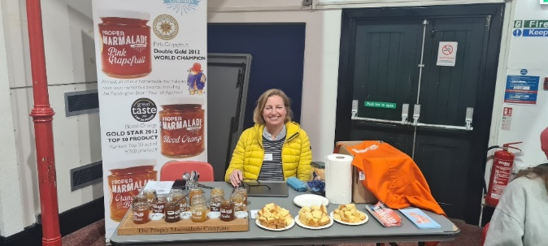

Be a part of this leading business & tourism association and be a voice for Ilfracombe – contact us for details email: ilfracombetourismassociation@gmail.com

